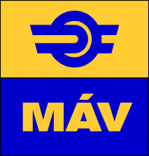

**MÁV Zrt.**

**Procurement Directorate General**

Subject: Questions received after the preliminary market consultation and answers

Presented by: dr Zsanett Váradi

Mobile: +36-30/827-39-75

1. Sheet of submission of indicative proposal

On which Incoterm (Incoterms 2020) shall the requested net prices be based on?

Answer: The requested net prices are to be determined under Incoterm (Incoterms 2020)! DDT parity, delivery to designated teminal.

2. Technical specification of the multifunctional (MFMT) measurement train, 5. The requirements of the onboard devices for ETCS-inspection

Who is the supplier of the ETCS trackside system?

Answer: The ETCS L1 and L2 trackside sub-systems installed so far on the MÁV network have been received from 2 suppliers:

* **Thales** Austria GmbH/Thales Deutschland + Thales RSS Kft. (Branch office in Hungary),
* **Siemens** Mobility CH/Siemens Mobility DE + Siemens Mobility Kft. (Branch office in Hungary),

Budapest, November 16, 2020